List
A List can be defined as a collection of values or items of different types. Lists are very similar to array but there is major difference, an array can store only one type of elements whereas a list can store different type of elements. List are mutable so we can modify its elements. The items in the list are separated with the comma (,) and enclosed with the square brackets []. Example: a = [10, 20, -30, 22.1,” python”]
Python Create list
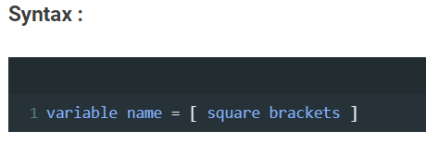
Example 1:
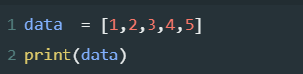
OUTPUT
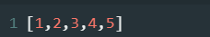
Example 2:
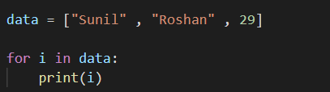
OUTPUT
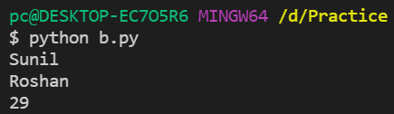

Python list slicing & Indexing
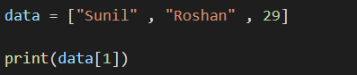
OUTPUT
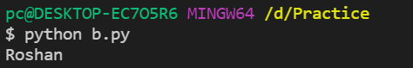
Example 2:
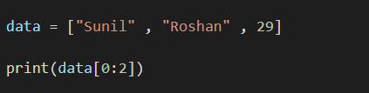
OUTPUT
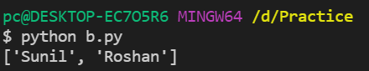

Creating lists Using Range () Function
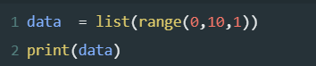
OUTPUT
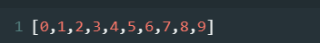

Python list append
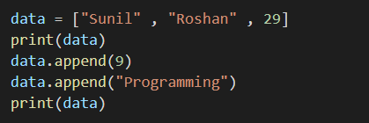
OUTPUT
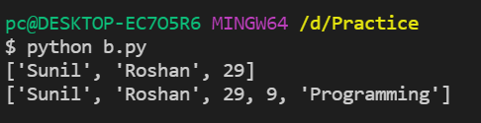
Python list insert
The insert() method inserts and element to the list at the specified index. This method can be used to insert a value at any desired position. It takes two arguments-element and the index at which the element has to be inserted.

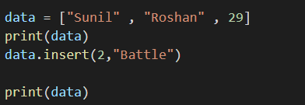
OUTPUT
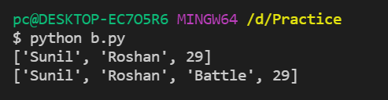

Inserting a Tuple (as an Element) to the List
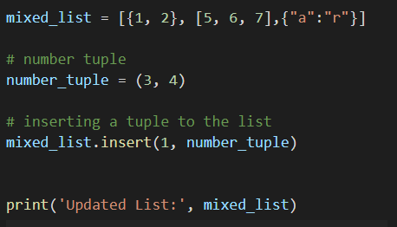
OUTPUT
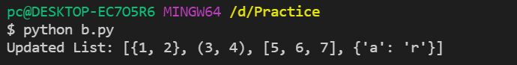

Updating the elements of a List

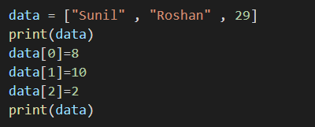

OUTPUT

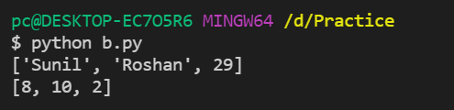

Python list del function

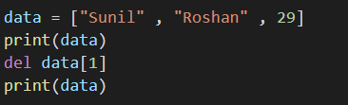

OUTPUT

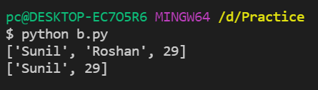

Python list remove

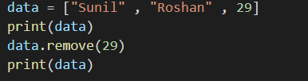

OUTPUT

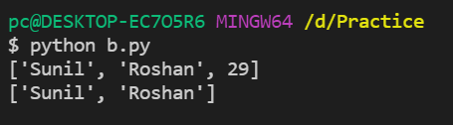

Python list pop

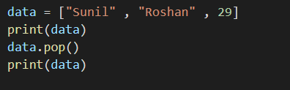

OUTPUT

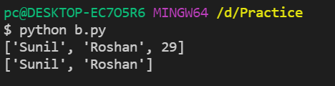

Concatenation of two lists

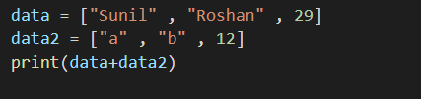

OUTPUT

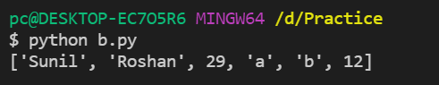

Python list copy

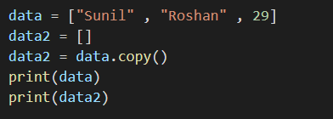

OUTPUT

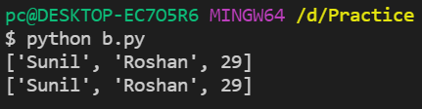

Python list extend

The extend() method adds the specified list elements (or any iterable) to the end of the current list.

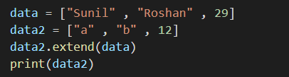

OUTPUT

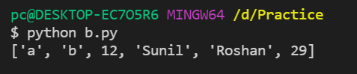

Python list Clear

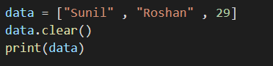

OUTPUT

